ECIF

Selection of raised water level areas and pumped areas on Somerset Levels and Moors

Background

The Somerset Levels and Moors (SLM) Environmentally Sensitive Area (ESA) extends over 29,260 hectares of the central Somerset lowlands, bounded by the Mendips to the north, low limestone escarpments to the east, the Blackdown Hills to the south and the Quantock Hills to the west. The moors comprise an extensive area of very low-lying basin peat, with a few remnants of raised bog, surrounded by alluvial clay and silt. The peat is overlain by riverine clay. Westwards from the moors lies an extensive area of slightly higher estuarine alluvium known as the Levels, most of which is excluded from the ESA. Grassland predominates and, traditionally, has been used for summer cattle grazing and hay cutting. The ecological interest is associated with the wet, often species-rich pastures and meadows and the surrounding network of ditches with their aquatic flora and invertebrate interest. This wet grassland area supports over-wintering wildfowl and breeding waders for which part of the area is designated as a Ramsar/SPA site

The land has been managed since Medieval times, but particularly since WWII, when large pumping stations were built to control water levels. Much of the land has “improved” or converted to arable land by lowering water levels in winter, thus allowing machinery to be used, and the application of chemicals and fertilisers has increased. Other land has been reserved for nature conservation with the designation of 13 moors as Sites of Special Scientific Interest (SSSIs) and the establishment of the area as an ESA.

As part of ESA management, a scheme was started in 1987 to encourage farmers to conserve the ecological quality of farmed land. The scheme offers different payments to farmers for achieving different set of targets, called tiers. Differential take-up of the scheme has resulted in areas of the SLM that are still intensively managed (Tier 1), normally with low (pumped) winter water levels and other areas with raised winter water levels (Tier 3).

GIS layers

GIS data for the ESA tiers are held by JNCC. Contact points were provided by John Leece (ESA raised water level officer based at Natural England).

Hydrological regimes

In broad terms, to achieve Tier 3, ditch water levels should be maintained at mean field level during the winter (1 December – 31 March) for wintering birds (solid green line in Figure 1) or up to 150 mm below the surface for breeding birds (dashed green line in Figure 1). In summer the level is generally around 300 mm below mean field level.

In areas of the SLM wetlands where intensive agriculture is the main priority, water levels are reduced in winter by pumping, though to achieve Tier 1, some water must be left in the ditches (solid brown line in Figure 1); for Tier 2 the water level must not be more than 450 mm below the surface. In summer, water levels are raised to provide wet fencing and drinking water for cattle (on grazed land). Typically water levels are 300-450 mm below the surface.

In summary, the major difference in hydrological regimes is apparent in the winter, with intensive farmland drained and conservation areas saturated. In summer, water levels are approximately the same, with levels slightly lower in farmed land.

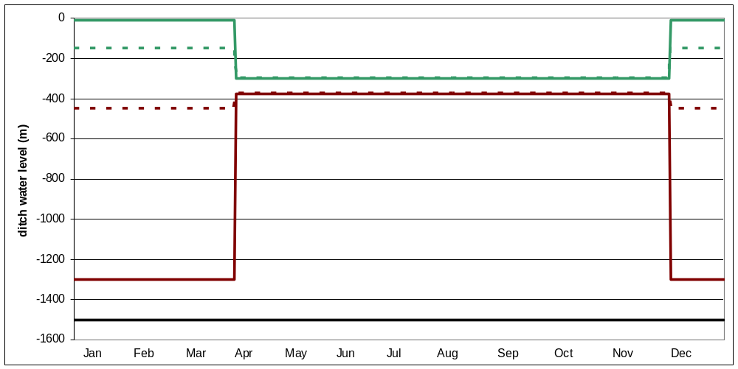
The

Figure 1 Water level regimes for a typical year on the Somerset Levels and Moors (green lines conservation areas, brown lines intensively farmed areas)

ECIF Hypothesis

The approach proposed fro ECIF is to identify zones of SLM in Tier 1 and zones in Tier 3 to test the hypothesis that mosquito numbers, and the pathogens they carry, are influenced by wetland water level.

Selection of experimental areas

In discussions with John Leece, moorland areas with consistent hydrological regimes were identified. Table 1 gives some preliminary information. Aller Moor, East and West Waste and Sutton Moor provide examples of intensive farmer, with Tier 1 water levels. Ham Wall, Moorlinch, Kings Sedge Moor, Wet Moor and West Sedge Moor are examples of raised water level areas.

Also given are examples of villages near to each moor that could be sampled. However, in some cases villages are equally proximate to wet and pumped areas, so care would be needed in choosing sites and interpreting results.

Sampling points

Initial contact has been made with people living in and around the SLM who would, in principle, be willing to manage insect traps. These are given in Table 2. Once a definitive set of sampling sites has been selected, individuals can be contacted.
Table 1 Example moors within SLM ESA with raised water levels or pumped regimes

Moor area | Regime | Location (grid ref) | Contact | Near-by villages to sample
Aller Moor | Pumped drained | 339 128 | Peter Maltby, Aller Court Farm | Aller
East and west waste | Pump drained | 347 141 |  | Godney
Sutton Moor | Pump drained | 343 133 |  | Henley
Ham Wall | Reed beds | 346 139 | RSPB, Meare | Meare
Moorlinch | Tier 3 | 339 135 | Natural England | Moorlinch
Kings Sedge Moor | Tier 3 | 341 133 | Natural England | Beer
Wet Moor | Tier 3 | 344 124 | Natural England
West Sedge Moor | Tier 3 | 336 126 | RSPB

Table 2 Locations of people interested in operating insect traps

Village/town | Location (grid ref)
Ashcott | 3435 1372
Chilton Polden | 3375 1438
Meare | 3456 1416
Wedmore | 3436 1475
Burnham-on-Sea | 3315 1495
Bridgwater | 3280 1365
Pawlett | 3297 1426
North Petherton | 3292 1331

Contact with vet

The veterinary practice in Cossington was contacted. The vets were busy at the time but agreed to help with identifying mosquito-borne diseases suffered by cattle and other animals in their practice.

